

Disability Access and Inclusion Plan
2026-2031
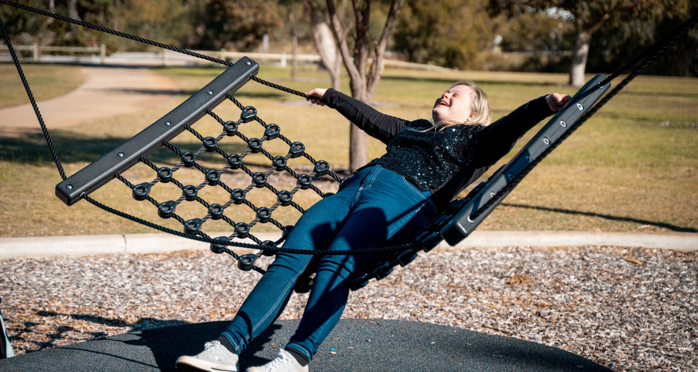

Contents
Disability Access and Inclusion Plan 2026-2031 1
Contents 2
Acknowledgement of Country 4
Alternative Formats 4
Message from the Mayor 5
Why do we have a Disability Access and Inclusion Plan? 6
What is a Disability Access and Inclusion Plan? 6
The Seven Outcome Areas 7
Why this Plan is called the Disability Access and Inclusion Plan 8
Definitions 8
Alignment with other City of Mandurah Strategies 9
About Mandurah and our Disability Community Profile 10
Mandurah at a Glance 11
Community Population Snapshot 12
National and State Overview 12
Disability and Support in Mandurah 12
Workforce Participation 13
Mandurah Local Economy 13
Accessibility and Economic Impact 14
Sources 14
Planning for Disability Access and Inclusion 15
Access and Inclusion Advisory Group 16
Progress and Achievements since 2021 17
Outcome Area One 17
Outcome Area Two 18
Outcome Area Three 18
Outcome Area Four 18
Outcome Area Five 19
Outcome Area Six 19
Outcome Area Seven 19
Community Leadership and Impact 20
Development of the Disability Access and Inclusion Plan 2026-2031 20
Review of the AIP 2021-2026 21
Community Engagement Process 21
Community Engagement Outcomes 22
Communicating, Implementing and Reporting on the Disability Access and Inclusion Plan 22
Disability Access and Inclusion Plan 2026-2031 Implementation Plan 23
Outcome One: 24
Outcome Two: 32
Outcome Three: 41
Outcome Four: 50
Outcome Five: 55
Outcome Six: 58
Outcome Seven: 62
Disability, Access and Inclusion Guiding Principles 69
Understanding disability through the social model 69
Valuing strengths through Asset-Based Community Development 69
Accessibility and inclusion 69
Universal design 70
Shared responsibility and partnership 70
Language used in this Plan 71
Contact Us 71

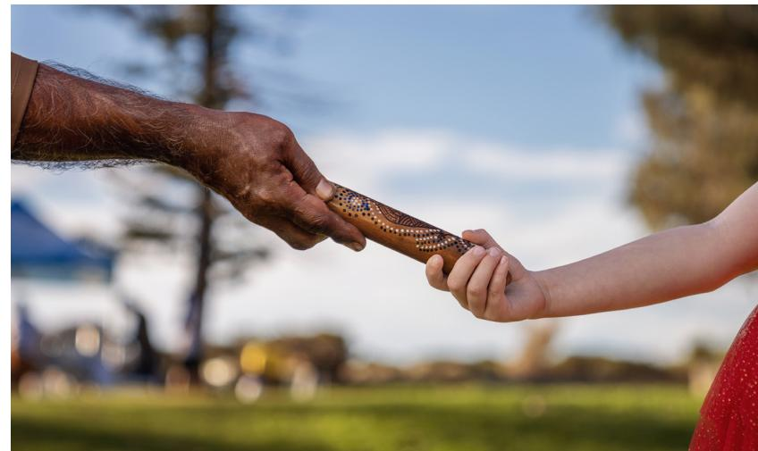

Acknowledgement of Country
The City of Mandurah would like to acknowledge the Bindjareb people, the Traditional Custodians of this land, and pay respect to all Elders, past and present.
We wish to acknowledge and respect their continuing culture and the contribution they make to the life of this City and the region.

Alternative Formats
Easy Read, plain text, and audio versions of the plan are available to download from the City’s website. These formats can be accessed online at any time.
For more information or to request an alternative format, contact the Heritage and Community Capacity team at the City of Mandurah on (08) 9550 3777 or hcc@mandurah.wa.gov.au

Message from the Mayor
There are so many things that make Mandurah a special place to live, but above all, it’s the way our community shows up for each other, and our shared belief that everyone should feel included and connected to the place they call home.
That’s what this Disability Access and Inclusion Plan is all about.
Through this Plan, we’ve set the direction for how we continue to remove barriers, improve access, and create more opportunities across our city. It guides how we design our spaces, deliver our services and events, and share our information so it works for everyone.
We know inclusion isn’t something one team or even one organisation can achieve on its own. It comes from conversations with people who bring lived experience, who can share not only the challenges they face, but also what really makes a difference.
This plan has been shaped by those voices, and I want to thank everyone who contributed their ideas and their insights to help shape a plan that reflects what our community needs, now and into the future.
We’ve made strong progress in this space over the past few years. Being recognised as Western Australia’s Most Accessible Community is something we can all be proud of. But we also know there’s always more to learn and more we can do.
As Mandurah continues to grow, this Plan gives us a clear and practical path forward, strengthening access, inclusion and participation in everyday life.
At the end of the day, it’s important that everyone feels like they belong, and that’s exactly the kind of Mandurah we’re building together.
Amber Kearns,
City of Mandurah Mayor


Why do we have a Disability Access and Inclusion Plan?
The City of Mandurah is committed to being a vibrant city that delivers possibility for everyone.
The City of Mandurah’s Disability Access and Inclusion Plan (DAIP) provides a framework to improve access and inclusion for people with disability across community life. It supports identifying and addressing barriers, as well as embedding accessibility into planning, design, and service delivery across the City’s services, facilities, information, employment practices, and community spaces. It reflects the City’s commitment to creating a welcoming, inclusive and liveable community where diversity is valued and where people can participate in, and contribute to, community life.
The DAIP is also a legislative requirement under the Disability Services Act 1993 (WA), which requires local governments to plan for improved access and inclusion for people with disability. Through the DAIP, the City of Mandurah translates these obligations into practical actions that respond to local needs, support universal design, and promote dignity, independence and social connection. When we create a community that is accessible for people with disability, we help to create a more inclusive city for everyone.

What is a Disability Access and Inclusion Plan?
A Disability Access and Inclusion Plan (DAIP) is a formal, legislated plan that sets out how an organisation will ensure people with disability can access and participate in its services, facilities, information, employment and events on an equal basis with others.
In Western Australia, all public authorities (including State Government agencies and local governments) are required by law to develop, implement, maintain, and report on a current DAIP.
A DAIP is structured around seven mandatory outcomes set out in the legislation and regulations:
- Services, programs and events are accessible to people with disability
- Buildings and facilities are accessible
- Information and communication are available in accessible formats
- Quality of service is equitable for people with disability
- Complaints processes are accessible and inclusive
- People with disability can participate in all public consultation
- People with disability can access employment and volunteering opportunities.

The Seven Outcome Areas
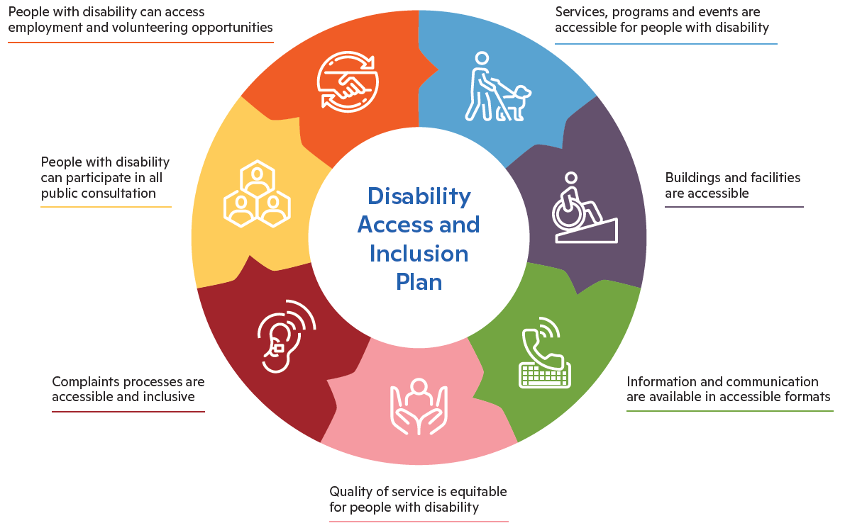
Transcriber’s Note: The image above is an infographic showing seven outcome areas as elements of a circle that make up the Disability Access and Inclusion Plan:
- Services, programs and events are accessible to people with disability
- Buildings and facilities are accessible
- Information and communication are available in accessible formats
- Quality of service is equitable for people with disability
- Complaints processes are accessible and inclusive
- People with disability can participate in all public consultation
- People with disability can access employment and volunteering opportunities.

Why this Plan is called the Disability Access and Inclusion Plan
This document is titled the Disability Access and Inclusion Plan to clearly reflect its purpose and focus toward improving access and inclusion for people with disability. The title provides clarity about the intent of the Plan, while recognising that actions delivered through the Plan also benefit the broader community.
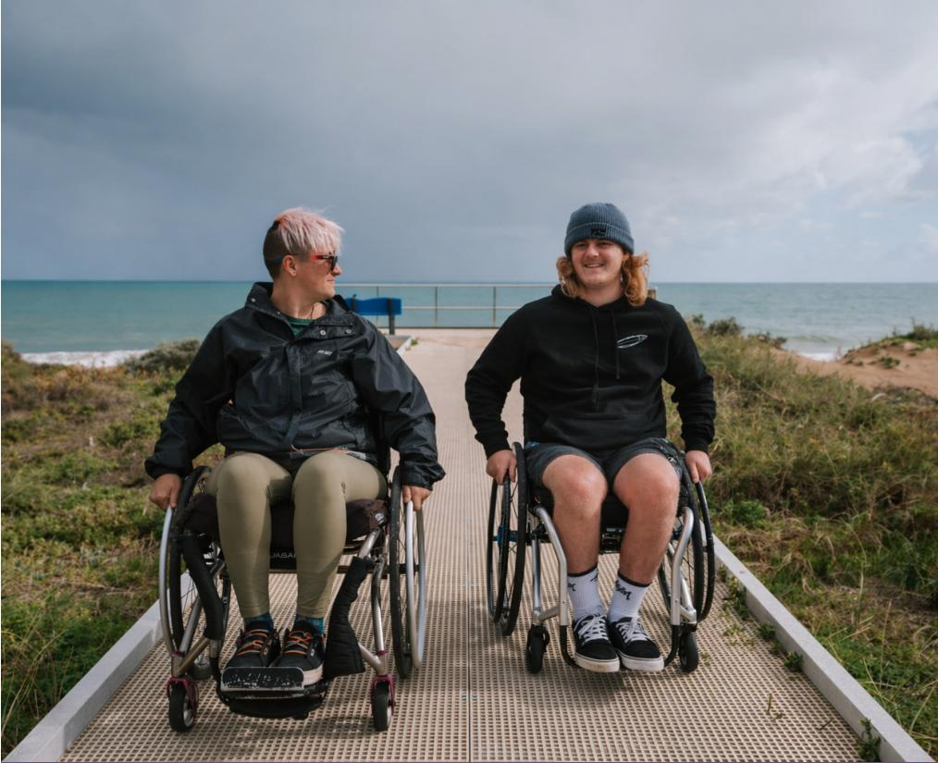

Definitions
Throughout this DAIP, we use the words disability, access and inclusion.
Disability
Disability refers to a range of physical, sensory, cognitive or psychosocial conditions that may be permanent, temporary or episodic, and which impact a person’s ability to participate in everyday life.
Access
Access means people with disability can get to and use buildings, places, services, information and events. This includes reducing or removing barriers that may limit participation.
Inclusion
Inclusion means people with disability are considered from the outset in the planning and delivery of places, services and activities. It extends beyond access, focusing on meaningful participation in community life, including the opportunity to contribute, connect and experience a sense of belonging.
The actions in this plan support a range of ability needs. They are not grouped by disability type. They include support for both visible and non-visible disability needs.

Alignment with other City of Mandurah Strategies
The DAIP aligns with other City strategies and plans to support a coordinated approach to identifying and reducing barriers for people with disability across the City.
Strategic Community Plan
The DAIP aligns with the City of Mandurah’s Strategic Community Plan by supporting a community where everyone can participate and feel connected. The Plan contributes directly to priorities around inclusive places and spaces, access to services, safe and connected communities, and well-planned, accessible facilities. By embedding disability access and inclusion into planning, service delivery and engagement, the DAIP supports the Strategic Community Plan’s intent to ensure community infrastructure, services and decision-making respond to the needs of people with disability as part of broader community planning.
The following Strategic Community Plan actions are identified as those most closely aligned with the intended objectives and actions of the Disability Access and Inclusion Plan 2026-2031:
- 2.1. Access to support services that enhance opportunities for everyone
- 2.2. Safe and connected communities
- 2.3. Inclusive and welcoming places, spaces and neighbourhoods
- 2.4. An enriched, creative, and empowered community that values culture, heritage, and lifelong learning
- 2.5. A healthy lifestyle and healthy community, with an emphasis on prevention
- 3.4. Our built environment is clean, accessible, and sustainable
- 4.1. A clear and shared vision for Mandurah’s future
- 4.2. Sound decisions based on evidence and meaningful engagement
- 4.3. Effective advocacy focused on the needs of the community and strong relationships with key stakeholders
- 4.4. Well-maintained assets and facilities that meet the needs of our community
- 4.6. A committed, innovative, effective, and values driven Council and workforce.
All Council-endorsed plans and strategies consider inclusion, although ones with a heightened focus that support improved access and inclusion are:
- Corporate Business Plan 2026-2030
- Local Emergency Management Arrangements General Plan 2024 and Sub Plans
- Place Enrichment Strategy 2023-2027
- Youth Strategy 2021-2026
- Arts and Culture Strategy 2023-2028
- Child Safe Plan 2024-2027
- Community Infrastructure Plan 2025
- Festivals and Events Strategy 2026-2030
- Public Health Plan 2026-2030

About Mandurah and our Disability Community Profile
The City of Mandurah is a major regional centre located 72km south of Perth, with an estimated population of 106,827 people and a strong role in servicing both residents and surrounding communities. Known for its natural assets and relaxed coastal lifestyle, Mandurah supports a diverse local economy including health, retail, tourism and education. The City comprises 18 suburbs and its facilities, services and public spaces play an important role in community life across the region.
Mandurah’s population profile has important implications for service planning and delivery. The community is older than the Western Australian average, with a median age of 45 and more than a quarter of residents aged 65 and over. In addition, 6.6% of residents report needing assistance with support for everyday tasks, and 11.5% provide unpaid care to family or friends. The prominence of the Health Care and Social Assistance sector, employing 13.5% of residents, further reflects the level of support required within the community, including services connected to the National Disability Insurance Scheme.
These factors highlight the importance of accessible and inclusive infrastructure, services and public spaces that support independence and participation. Higher rates of ACROD parking permits also indicate significant mobility needs within the community. The Disability Access and Inclusion Plan 2026-2031 provides a strategic framework to respond to these needs, supporting improved access, inclusion, and wellbeing for people with disability, carers, older people, and the broader community.

Mandurah at a Glance
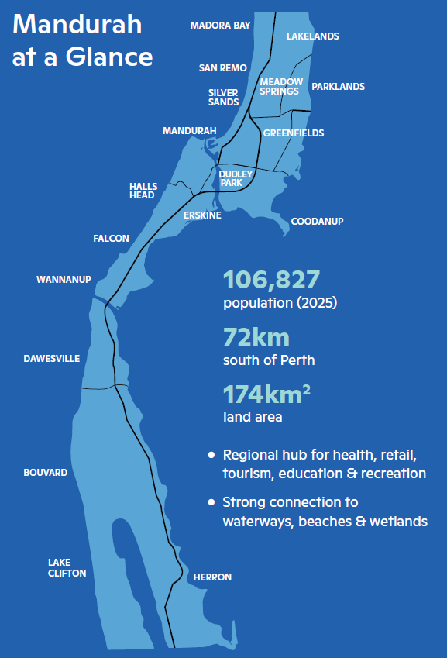
Transcriber’s Note: The map above shows the City of Mandurah, with the following suburbs marked: Madora Bay, Lakelands, San Remo, Silver Sands, Meadow Springs, Parklands, Mandurah, Greenfields, Dudley Park, Halls Head, Erskine, Coodanup, Falcon, Wannanup, Dawesville, Bouvard, Lake Clifton, and Herron.
Listed on the side of the map are the following highlights:
- Population in 2025: 106,827
- 72 kilometres south of Perth
- Land area: 174 kilometres squared
- Regional hub for health, retail, tourism, education & recreation
- Strong connection to waterways, beaches & wetlands

Community Population Snapshot
- Children (0-9 yrs): 11.1% of the population
- Youth (10-19 yrs): 11.8% of the population
- Aged (65 and over): 25.6% of the population

Key Indicators
- Median age: 45 years old (WA: 38)
- Number of families: 25,111
- Average number of children per family: 1.8
- Average number of people per household: 2.4

What this means
Mandurah has a significantly older population, with more than 1 in 4 residents aged 65+. This drives increased demand for:
- Accessible infrastructure
- Inclusive services
- Age-friendly community design.

National and State Overview
- 5.5 million people in Australia have disability (21.4%)
- 411,500 people in Western Australia have disability

Disability and Support in Mandurah
- People needing assistance: 5,954 (6.6%)
- Unpaid carers: 8,611 (11.5%)

Accessibility Indicator
High rate of ACROD permits relative to other Local Governments in WA indicates greater mobility support needs

What this means
- Many people with disability use formal and informal supports
- Growing need for accessible places, transport, and services
- Inclusion is essential for community participation and wellbeing.

Workforce Participation

Participation Rate:
- 84.9% of people without disability work
- 60.5% of people with disability work

Unemployment Rate:
- People without disability: 3.1%
- People with disability: 7.5%

What this means
People with disability are less likely to be employed and more likely to be unemployed compared to people without disability.

Mandurah Local Economy

Health Care and Social Assistance:
- Largest employment sector in Mandurah
- Includes disability and community services
- Reflects high demand for accessible and inclusive services, places and spaces.
13.5% of employed residents

Accessibility and Economic Impact
Research commissioned by the City of Melbourne found that participating businesses in the study generated an estimated $13 in additional revenue for every $1 invested in accessibility improvements. This highlights that accessibility can support both inclusion and economic activity.
Tourism Research Australia reports that travellers with accessibility needs were involved in 23 per cent of domestic day trips nationally. If Western Australia reflects national trends, a similar share of day trips in WA may involve travellers with accessibility needs.

Sources
Data from the “About Mandurah and our Disability Community Profile” section has been referenced from the following sources:
- Profile.id, Estimated Resident Population (ERP) as of the 30th June 2025, City of Mandurah.
- Australian Bureau of Statistics, 2021 Census QuickStats, City of Mandurah local government area.
- Australian Bureau of Statistics, 2021 Census, Assistance Needed for Core Activities, City of Mandurah local government area.
- Profile.id, Unpaid Care, City of Mandurah, 2021 Census.
- ABS survey of Disability, Ageing and Carers (SDAC, 2022)
- WA State Disability Strategy 2020-2030
- National Disability Services (WA), ACROD Parking Program data, Western Australia.
- Monash University and University of Technology Sydney 2021, Putting a dollar value on accessibility, commissioned by the City of Melbourne.
- Tourism Research Australia, Accessible Tourism in Australia, Australian Trade and Investment Commission, 2024, accessed 29 April 2026, www.tra.gov.au.
- Australian Institute of Health and Welfare, People with disability in Australia, Participation and inclusion, latest edition.
- Profile.id, Industry of Employment, City of Mandurah residents, 2021 Census.

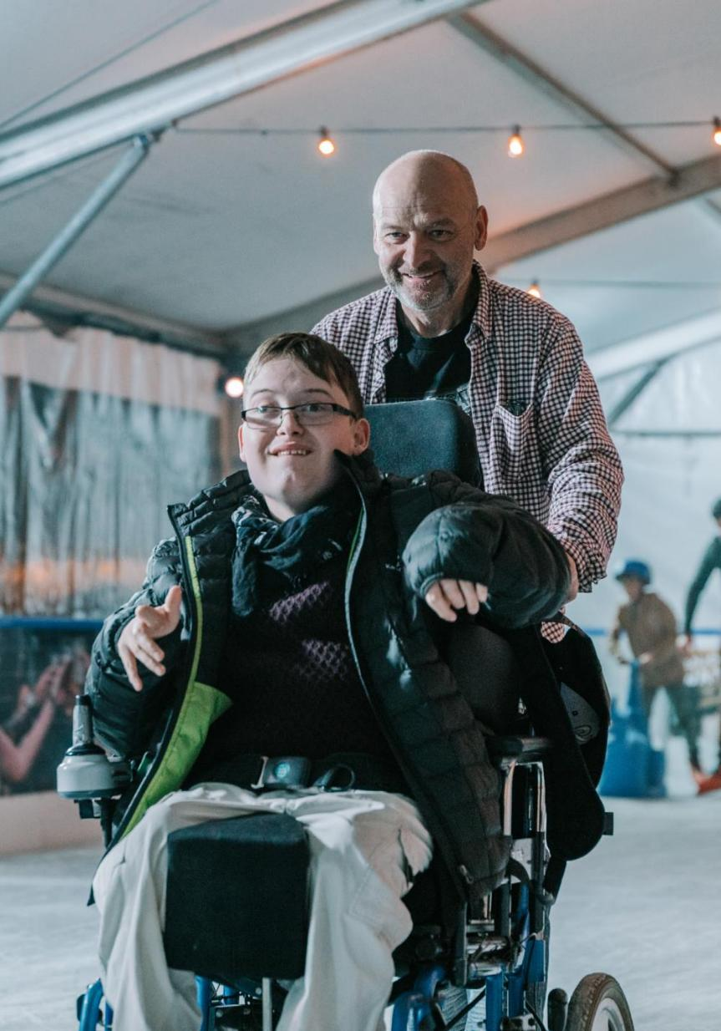

Planning for Disability Access and Inclusion
The City of Mandurah recognises people with disability as valued members of the community and acknowledges their contribution to the social, cultural and economic life of the City. The way in which community facilities, services, programs and information are planned, designed and delivered is fundamental to enabling participation for people with disability.
The Disability Access and Inclusion Plan (DAIP) 2026-2031 builds on the City’s established and ongoing commitment to improving access and inclusion across all areas of its operations.
Approaches to disability support in Western Australia have evolved significantly over time, transitioning from institutional models of care to community-based living that emphasises individual choice and control. The introduction of the National Disability Insurance Scheme (NDIS) has provided individualised supports. While these reforms are in place, meaningful participation in community life continues to depend on the accessibility of public spaces, services, programs and information.
Local government plays an important role within this broader service system, working in partnership with State and Commonwealth governments, service providers and the community.
The DAIP is prepared in accordance with the Disability Services Act 1993 (WA) and provides a structured framework for identifying and addressing barriers, and for guiding ongoing improvements in access and inclusion for people with disability.
The City’s planning and implementation of disability access and inclusion initiatives is also informed by the following legislative and policy frameworks:
- Disability Discrimination Act 1992, including the Disability (Access to Premises - Buildings) Standards
- Building Code of Australia
- Australia’s Disability Strategy 2021-2031
- National Autism Strategy 2025-2031
- Equal Opportunity Act 1984
- United Nations Convention on the Rights of Persons with Disabilities
- A Western Australia for Everyone: State Disability Strategy 2020-2030.

Access and Inclusion Advisory Group
The City of Mandurah’s Access and Inclusion Advisory Group has an advisory role in supporting the City to create an inclusive, accessible, and welcoming community for people of all abilities.
The group provides feedback to the City on policies, plans, services, and projects, with a particular focus on improving access and inclusion for people with disability, their families, carers, and the wider community. It supports the development, implementation, and review of the City’s DAIP, advocates for best-practice universal design, and helps identify barriers to participation in civic life. Through collaboration between community members, stakeholders, and the City, the group helps ensure that access and inclusion considerations are embedded across City decision-making and service delivery.
The Access and Inclusion Advisory Group makes a meaningful difference and will be integral to delivering many actions contained within the DAIP.
Thank you to everyone who has participated as a member of this group over the years. Your commitment, advice, information and feedback is incredibly valuable.
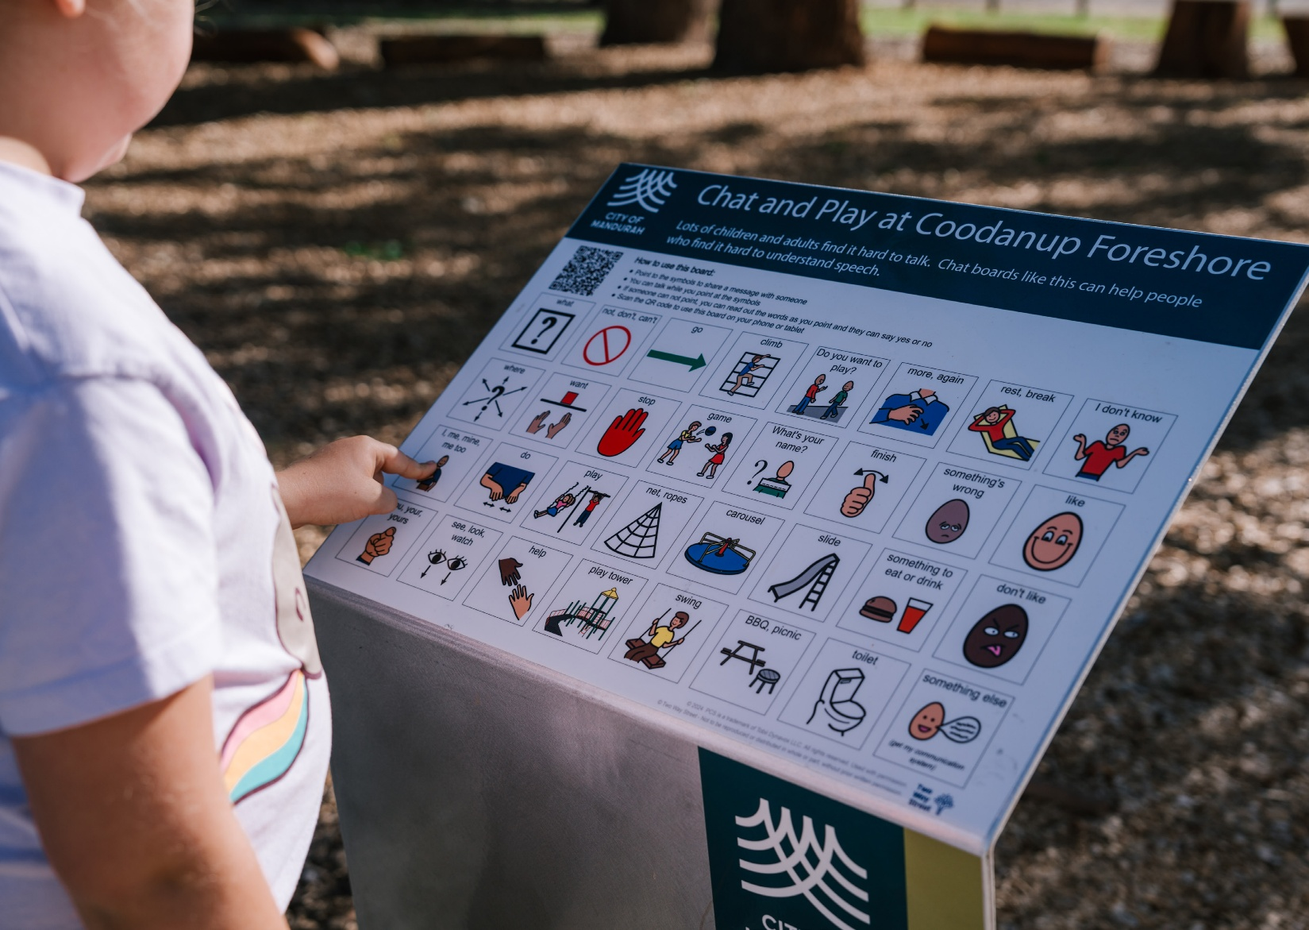

Progress and Achievements since 2021
From 2021 to 2026, progress was delivered across all outcome areas of the Disability Access and Inclusion Plan through practical initiatives and collaboration with people with disability and community partners. This work was recognised with the City being named overall winner of the Most Accessible Community in WA Awards in 2021, 2023 and 2025, reflecting continued focus on improving disability access and inclusion across Mandurah.

Outcome Area One
People with disability have the same opportunities as other people to access the services of, and any events organised by, the City of Mandurah.
- Christmas in Mandurah events were made accessible through an accessibility map and audio descriptions for the Christmas Lights Trail, and visual communication supports across key events.
- Crab Fest includes a Chill-Out Zone and sensory container, supported by an Accessibility Guide and Hidden Disabilities Sunflower training for volunteers.
- Tactile bin lids and stickers support independent waste management for people with vision impairment.

Outcome Area Two
People with disability have the same opportunities as other people to access the buildings and other facilities of the City of Mandurah.
- An All-Ability Paddle Launch facility was delivered as the first of its kind in Western Australia.
- The Mandurah Waterfront project delivered connected, accessible movement between the Eastern and Western Foreshores, supported by facilities such as a Changing Places facility, ramped access to the Kwillena Gabi Pool and beach, and inclusive play equipment and communication boards.
- Delivered Universal Access Toilets at public facilities, with full coverage to be completed in 2026/27.

Outcome Area Three
People with disability receive information from the City of Mandurah in a format that will enable them to access the information as readily as other people are able to access it.
- Communication boards provided across public open spaces, facilities and events to support people with communication challenges.
- Information on accessible facilities, programs and services provided in print and online formats, improving access to information.
- My Community Chat Cards were introduced to support people with disability and support networks explore inclusive activities and facilities in Mandurah.
- Increased and formalised networking opportunities, strengthening connection, information sharing and participation for people with disability, and the disability sector.

Outcome Area Four
People with disability receive the same level and quality of service from City officers as other people receive.
- Customer service employees across the organisation trained on the Hidden Disabilities Sunflower initiative to support more inclusive and informed service interactions.
- Annual disability awareness training strengthened employee understanding of disability and inclusive practice across the organisation.
- Introduced clear and easy to find information on the City’s website about disability facilities, services, activities and resources, improving access to information and supporting more informed customer service responses.

Outcome Area Five
People with disability have the same opportunities as other people to make complaints to the City of Mandurah.
- City officers met with the Access and Inclusion Advisory Group to support the development of a more inclusive and accessible complaints framework.
- Complaints were managed through telephone, email and face-to-face channels, with interactions also providing opportunities to connect people with disability to local programs and services.

Outcome Area Six
People with disability have the same opportunities as other people to participate in any public consultation by the City of Mandurah.
- Targeted engagement undertaken through disability networks, education support schools and service providers, ensuring the voices of people with disability informed City planning and decision making.
- Engagement materials were strengthened to improve accessibility, including hard copy formats and more accessible online content.
- Major City projects were presented to the Access and Inclusion Advisory Group at key stages, embedding access and inclusion considerations throughout project development.
- A Beach Access Review, facilitated by Spinal Life Australia and supported by City officers, enabled people with disability to directly assess beach accessibility.

Outcome Area Seven
People with disability have the same opportunities as other people to obtain and maintain employment with the City of Mandurah.
- Customised employment delivered to build awareness of inclusive employment practices across Mandurah.
- Exploration days and customised employment trials implemented for people with disability, resulting in two positions being offered to people with disability.
- A disability traineeship provided, delivered in partnership with a local disability employment service provider.
- The Workforce Diversity and Inclusion Strategy 2022 guides inclusive employment within the City, supported by an internal working group.

Community Leadership and Impact
Alongside the City’s progress under this Plan, strong leadership has been demonstrated across the Mandurah community. Through the City of Mandurah Community Grants Program, targeted funding has supported initiatives that have developed into sustainable and valued community programs.
These initiatives expand opportunities for people with disability to participate, contribute and connect within community settings, strengthening inclusion and active participation across Mandurah.
Examples of this work include inclusive sport and recreation initiatives, peer support networks, inclusive social programs, capacity building workshops focused on employment and digital access, and creative arts and performance programs.

Development of the Disability Access and Inclusion Plan 2026-2031
This DAIP has been developed to guide the City’s commitments to access and inclusion over the next five years. The steps taken by the City to develop the DAIP 2026-2031 are outlined below.
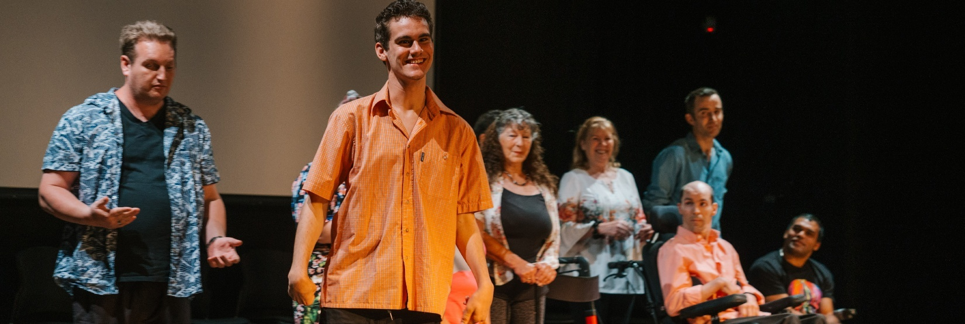

Review of the AIP 2021-2026
The previous AIP was reviewed and analysed to determine what worked well, what could be improved, any actions that were not completed, and the level of achievement. This provided valuable lessons learnt, enabling the City to build on established strengths, and embed continuous improvement into the design and implementation of the new DAIP.

Community Engagement Process
Community engagement informed the development of the City of Mandurah’s Disability Access and Inclusion Plan 2026-2031 and was undertaken to ensure the Plan is grounded in the lived experience, priorities and ideas shared by people with disability and the wider community.
The City designed and coordinated the engagement process and developed accessible tools to support participation by people with different access needs and communication preferences. E-QUAL Disability Consultants facilitated two in-person community workshops and one online workshop using City-developed tools, with an additional session facilitated by City officers. Workshops were held at various times across north, central and south Mandurah. An additional workshop was conducted specifically with City employees to inform actions within the Plan.
Engagement tools supported clear communication and meaningful feedback, recognising that people share ideas in different ways. These included flash cards, communication boards, mindful colouring sheets and a visual story to support participation. Feedback was guided by three consistent questions: what the City is doing well in the access and inclusion space, what could be improved, and ideas for future action. A survey provided additional feedback through multiple accessible formats, available online and in hard copy at community locations.
Community engagement information packs supported organisations to gather feedback in their own settings, alongside engagement through advisory groups, networks and pop-up activities at community venues and events. Engagement opportunities were promoted through City communication channels and community networks. In total, 341 submissions were received, informing the priorities and actions of the DAIP 2026-2031.
Key engagement activities also included:
- Access and Inclusion Advisory Group
- Elected Member feedback
- Youth Advisory Group
- Release of the Draft Access and Inclusion Plan 2026-2031 that encouraged feedback from the whole community.
All of these contributions helped shape the new DAIP.

Community Engagement Outcomes
People with disability acknowledged ongoing progress in access and inclusion across Mandurah and emphasised the importance of sustaining these efforts. Inclusion was consistently described as enabling meaningful participation, contribution and connection within community life, rather than solely providing physical access to facilities or services.
Respondents highlighted that positive experiences are most effective when approaches are applied consistently and supported by clear, accessible information. Awareness and understanding of disability, including invisible disabilities, were identified as critical to how people engage with City services, workplaces and community environments. Employment was also raised as an important aspect of broader participation and contribution.
These insights have directly informed the priorities and actions outlined in the City’s Disability Access and Inclusion Plan 2026-2031.

Communicating, Implementing and Reporting on the Disability Access and Inclusion Plan
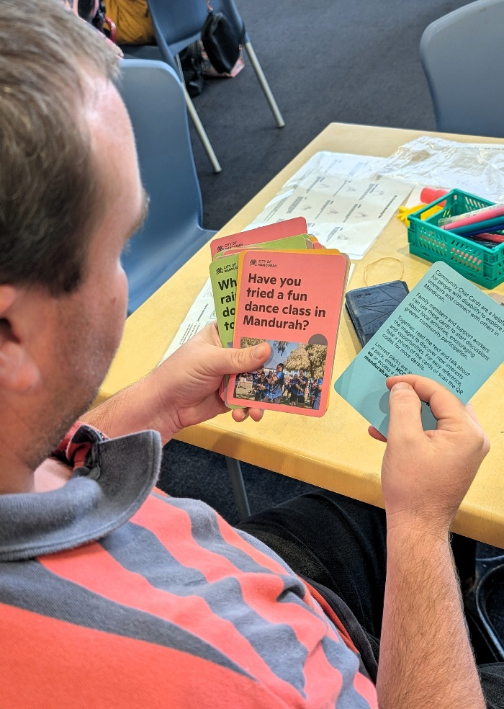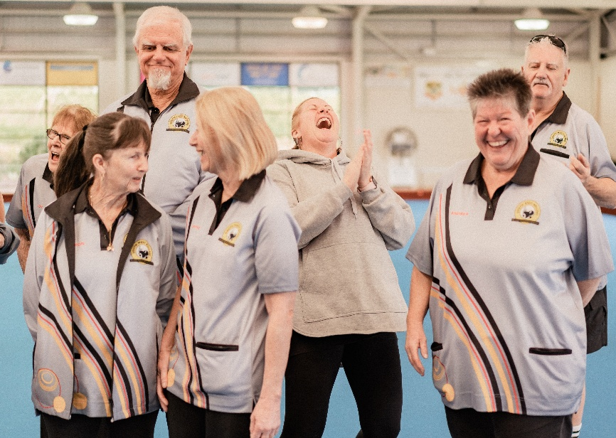
The Disability Access and Inclusion Plan (DAIP) will be communicated through established City and community channels, including City newsletters, social media platforms, and disability, access and inclusion pop-up events and networks. Presentations on the DAIP will also be made available, upon request, to disability service providers, schools and community groups.
The DAIP will be published on the City’s website and provided in accessible formats, including a text-only version compatible with screen readers, an Easy Read version in hard copy and PDF, and other alternative formats on request, such as large print, electronic formats and Braille.
Implementation of the DAIP will be supported through internal communication processes to ensure that all City officers, agents and contractors are informed of the Plan and their respective responsibilities.
Progress in implementing the DAIP will be reported annually to the Department of Communities, with key achievements also included in the City’s Annual Report.
For further information, contact the City of Mandurah on (08) 9550 3777 or council@mandurah.wa.gov.au

Disability Access and Inclusion Plan 2026-2031 Implementation Plan


Outcome One:
People with disability can access and participate in City of Mandurah services, programs and events in ways that meet their needs.
  - Embed inclusive and sustainable practices within City programs that support social connection, participation and wellbeing for people with disability of all ages.
  - Ensure access and inclusion for people with disability is incorporated in the planning and delivery of City-led and City-supported services and events.
  - Strengthen organisational capacity to consistently deliver inclusive services, programs and events.
  - Explore funding and partnership opportunities to support inclusive services, programs and events.

Projects/Actions | Existing Endorsed Long Term Financial Plan Operating Budget | Measures of Success | Lead | Organisational Partners
1.1.1 Deliver a health and wellbeing activity or program to support better health outcomes for people with disability. | - Year 1: FY 26/27  - Year 2: FY 27/28  - Year 3: FY 28/29  - Year 4: FY 29/30  - Year 5: FY 30/31 | 1. Stories of significant change.  2. Participant feedback and participation. | Health Promotion Officer | Coordinator Heritage and Community Capacity
1.1.2 (a) Pilot a low-sensory gym session at the MARC.  1.1.2 (b) If demand and practical requirements are evidenced, initiate session as part of regular programming. | - Year 1: FY 26/27 (a)  - Year 2: FY 27/28 (b)  - Year 3: FY 28/29 | 1. Pilot program is delivered.  2. Evidence of program outcomes inform future programming.  3. Participant feedback and participation. | Coordinator Recreation Services | Executive Manager Community Services  Coordinator Heritage and Community Capacity
1.1.3 Trial heightened inclusive approaches to regular programming within City facilities to further support participation by people with disability of different ages. | - Year 1: FY 26/27  - Year 2: FY 27/28  - Year 3: FY 28/29  - Year 4: FY 29/30  - Year 5: FY 30/31 | 1. Two trials per year are completed.  2. Outcome of trials inform future programming. | Coordinator Heritage and Community Capacity | Coordinator Library Services  Coordinator Recreation Centres  Coordinator Youth Development  Coordinator Arts and Culture
1.1.4 Trial social connection activities for people with disability aged 18+ at City run facilities in collaboration with facility-based teams. Evaluate participation to inform ongoing delivery. | - Year 2: FY 27/28  - Year 4: FY 29/30 | 1. Social connection activities are facilitated at City run facilities with evaluation informing future delivery.  2. Stories of significant change. | Coordinator Youth Development | Coordinator Heritage and Community Capacity  Coordinator Library Services  Coordinator Recreation Centres
1.1.5 Trial an inclusive activation or event within each of the City’s major Festivals and Events programs including but not limited to Crab Fest, Mandurah Arts Festival and Christmas in Mandurah. | - Year 1: FY 26/27  - Year 3: FY 28/29 | 1. Stories of significant change.  2. Participant feedback and participation.  3. Outcome of trial informs future programming. | Coordinator Festivals and Events | Manager Economic Development  Coordinator Arts and Culture  Coordinator Heritage and Community Capacity
1.1.6 Embed accessible process and delivery to City-led programming including but not limited to School Holiday Programming and Term Programming. | - Year 1: FY 26/27  - Year 2: FY 27/28  - Year 3: FY 28/29  - Year 4: FY 29/30  - Year 5: FY 30/31 | 1. Participant feedback and participation. | Executive Manager Community Services | Executive Manager Healthy Communities  Coordinator Heritage and Community Capacity  Coordinator Library Services  Coordinator Recreation Centres  Coordinator Youth Development
1.2.1 City-led events are consistently accessible, guided by the review, promotion and application of the City’s Accessible Event Guidelines to ensure continuous improvement. | - Year 1: FY 26/27  - Year 2: FY 27/28  - Year 3: FY 28/29  - Year 4: FY 29/30  - Year 5: FY 30/31 | 1. Evidenced use of the Accessible Event Guidelines for City-led events. | Manager Economic Development  Coordinator Festivals and Events | Coordinator Heritage and Community Capacity
1.2.2 Develop an accessibility statement for City events and implement ensuring inclusion in City communication. | - Year 1: FY 26/27  - Year 2: FY 27/28  - Year 3: FY 28/29  - Year 4: FY 29/30  - Year 5: FY 30/31 | 1. Accessibility statement included in communications for all City events.  2. Event delivery teams provided with guidance on preparing and including accessibility statements. | Marketing and Communications Officer  Community Services | Coordinator Heritage and Community Capacity
1.2.3 Promote the City of Mandurah’s Accessible Event Planning Guide to City-supported event organisers. | - Year 1: FY 26/27  - Year 2: FY 27/28  - Year 3: FY 28/29  - Year 4: FY 29/30  - Year 5: FY 30/31 | 1. Evidence of Accessible Event Guide being utilised from the City’s website.  2. Number of Accessible Event Guides provided to event organisers. | Manager Economic Development  Coordinator Festivals and Events  Coordinator Recreation Services | Coordinator Heritage and Community Capacity  Coordinator Arts and Culture  Coordinator Community Development
1.2.4 Complete a desktop review of Auslan inclusive events, engaging with the local Deaf community and propose City events for Auslan inclusion. | - Year 2: FY 27/28 | 1. City confirms proposed City-led events to include Auslan interpreter.  2. Community feedback. | Coordinator Heritage and Community Capacity | Executive Manager Community Services  Manager Economic Development  Coordinator Festivals and Events  Coordinator Civic Affairs
1.3.1 Deliver an accessible event workshop to City employees and to community members. | - Year 1: FY 26/27  - Year 2: FY 27/28  - Year 3: FY 28/29  - Year 4: FY 29/30  - Year 5: FY 30/31 | 1. Employee workshop delivered.  2. Participant feedback from training. | Coordinator Heritage and Community Capacity | Coordinator Festivals and Events
1.3.2 Develop a concise accessibility reference sheet that summarises tiered inclusion options for City events and add to the existing Accessible Event Guide. | - Year 3: FY 28/29 | 1. Reference sheet is completed and added to the City’s Accessible Event Guide. | Coordinator Heritage and Community Capacity | Coordinator Festivals and Events
1.4.1 (a) Collaborate with local disability service providers, community organisations and people with lived experience to deliver workshops that support people with disability to participate in local government elections.  1.4.1 (b) Advocate to WALGA to develop and deliver a Candidate Information Webinar with increased accessibility features that provides details about becoming an Elected Member for people who may be interested to nominate in upcoming elections. | - Year 1: FY 26/27  - Year 3: FY 28/29 | 1. Accessible “How to vote” sessions delivered prior to Local Government elections, supporting participation for people with disability.  2. Advocacy undertaken. | Executive Manager Community Services | Manager Governance and Legal Services  Executive Manager Healthy Communities  Coordinator Heritage and Community Capacity
1.4.2 Recognise International Day of People with Disability (IDPwD), partnering with community and service providers for events and activities. | - Year 1: FY 26/27  - Year 2: FY 27/28  - Year 3: FY 28/29  - Year 4: FY 29/30  - Year 5: FY 30/31 | 1. An event delivered to celebrate International Day of People with Disability (IDPwD) and promoted to the community.  2. IDPwD recognised and celebrated through activities across City facilities.  3. Service providers report positive engagement with participants.  4. Participants report positive engagement with stallholders. | Coordinator Heritage and Community Capacity | Marketing and Communications Officer Community Services
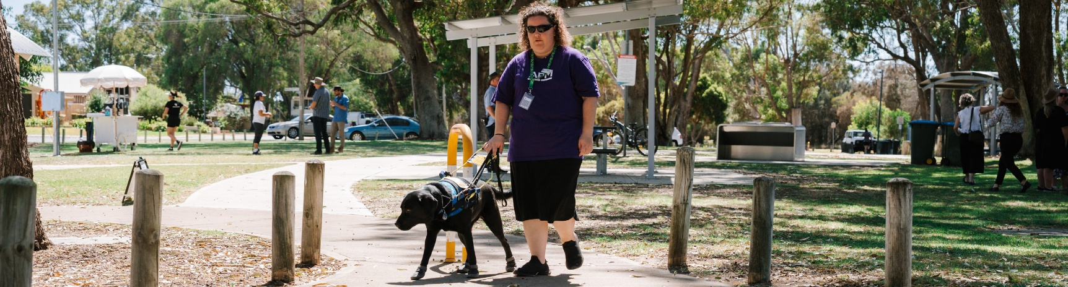

Outcome Two:
People with disability can access City of Mandurah buildings and facilities in ways that meet their access needs.
- Prioritise practical improvements to existing City buildings and public spaces to strengthen accessibility and inclusion in everyday use.
- Increase accessible toilet and adult change facilities in key locations and improve awareness of their availability.
- Improve the provision, location and usability of ACROD parking to better reflect community access needs across City facilities and public spaces.
- Integrate universal access and inclusive design into public open spaces, playgrounds, beaches and recreation areas to support shared participation.
- Strengthen the maintenance and reliability of accessible infrastructure to ensure access features are consistently available, functional, and safe for use.

Projects/Actions | Existing Endorsed Long Term Financial Plan Operating Budget | Measures of Success | Lead | Organisational Partners
2.1.1 Enhance accessibility of selected public art by incorporating audio descriptions and accessible information formats as part of project development. | - Year 1: FY 26/27  - Year 2: FY 27/28  - Year 3: FY 28/29  - Year 4: FY 29/30  - Year 5: FY 30/31 | 1. Audio descriptions developed and made publicly available for at least three priority public artworks each year.  2. Accessible information formats incorporated into all new public art installations. | Coordinator Arts and Culture | Coordinator Heritage and Community Capacity
2.1.2 Embed accessibility via the Project Management Framework for significant public art / tourism products to ensure there is consideration of how they can be universally accessible. | - Year 2: FY 27/28  - Year 3: FY 28/29  - Year 4: FY 29/30  - Year 5: FY 30/31 | 1. AIAG engaged to provide feedback on future public art / tourism projects.  2. Public art / tourism projects demonstrate accessibility. | Coordinator Arts and Culture | Manager Economic Development
2.1.3 Develop an internal accessibility guide that stretches beyond minimum compliance to assist City officers create facilities and public open spaces in a way that reflects the City’s commitment to access and inclusion. | - Year 3: FY 28/29 | 1. Beyond compliance accessibility guide developed and endorsed.  2. Guide applied in the planning and design of new and upgraded City buildings and public open spaces. | Director Place and Community | Executive Manager Community Services  Coordinator Heritage and Community Capacity
2.1.4 When there are City facilities and key public open space renewals, review existing mobility scooter recharge stations and designated parking areas. When City facilities are due for renewal or upgrade, develop project outcomes to inform future delivery. | - Year 1: FY 26/27  - Year 2: FY 27/28  - Year 3: FY 28/29  - Year 4: FY 29/30  - Year 5: FY 30/31 | 1. Ensure adequate mobility scooter recharge stations are installed at City facilities and key public open spaces.  2. Designated mobility scooter parking areas established at priority locations. | Executive Manager Community Services | Executive Manager Healthy Communities  Executive Manager Built Environment  Director Place and Community  Coordinator Heritage and Community Capacity
2.1.5 Use the Community Facilities Access Audit 2024 report to inform priority projects that enhance accessibility at identified facilities. | - Year 1: FY 26/27  - Year 2: FY 27/28  - Year 3: FY 28/29  - Year 4: FY 29/30  - Year 5: FY 30/31 | 1. Community Facilities Access Audit report reviewed and priority accessibility projects identified.  2. Identified priority projects incorporated into relevant capital works program.  3. Evidence of improved accessibility aligned with the 2024 report.  4. Feedback from users after the completion of works. | Manager Strategic Asset Management | Executive Manager Community Services
2.2.1 There are guidelines developed for the suitability and placement Universal Access Toilet (UAT) provisions, to inform new and upgraded facilities based on community need and usage patterns, recognising this may be beyond minimum compliance. | - Year 3: FY 28/29 | 1. Evidence of UAT provision based on need and usage in new and upgraded high-use City facilities.  2. Consideration of more than one UAT reflected in project design and delivery where suitable. | Executive Manager Community Services | Coordinator Heritage and Community Capacity
2.2.2 Explore the viability of an additional adult change facility at the Mandurah Aquatic and Recreation Centre (MARC). | - Year 2: FY 27/28 | 1.Feasibility assessment completed for an additional adult change facility at Mandurah Aquatic and Recreation Centre (MARC). | Executive Manager Healthy Communities | Coordinator Recreation Centres  Manager Project Management
2.2.3 Determine need and priority for additional Changing Places facility and apply for external grant funding to assist with the delivery. | - Year 1: FY 26/27 (Funding to be sourced external to the City of Mandurah to deliver on this item)  - Year 2: FY 27/28 | 1. External grant funding application submitted for a new Changing Places facility in a high-use location.  2. Funding outcome confirmed and next steps determined. | Executive Manager Community Services | Manager Project Management  Coordinator Heritage and Community Capacity
2.3.1 Review the usage of ACROD parking bays at new and upgraded City facilities to reflect demand and inform future parking projects or upgrades. | - Year 2: FY 27/28  - Year 3: FY 28/29 | 1. Ratio of ACROD parking bays incorporated into design of new and upgraded City facilities reflects the review.  2. Updated ACROD parking ratios reflected in project design and delivery. | Executive Manager Community Services  Executive Manager Development and Compliance | Executive Manager Built Environment
2.3.2 Install at least one Extra-Long ACROD Bay (ELAB), with clear signage, at applicable or upgraded high-use public parking areas. | - Year 2: FY 27/28  - Year 3: FY 28/29  - Year 4: FY 29/30  - Year 5: FY 30/31 | 1. At least one Extra-Long ACROD Bay (ELAB) installed before 2031 at applicable new or upgraded high-use public parking areas.  2. ELAB installation confirmed at project completion. | Executive Manager Built Environment | Manager Project Management  Manager Technical Services
2.3.3 Advocate to the National Disability Services (NDS) and the Australian Building Codes Board (ABCB) for a comprehensive review of the availability, location, and accessibility of ACROD parking bays to ensure adequate provision for individuals who use mobility aids. | - Year 3: FY 28/29  - Year 4: FY 29/30  - Year 5: FY 30/31 | 1. Advocacy paper submitted to the NDS and the ABCB for consideration and further action. | Executive Manager Community Services | Manager Commercial Services
2.4.1 Develop an Action Plan to improve access to beaches for people with disability. The plan will aim to identify barriers and outline prioritised staged improvements to ensure priority beaches are inclusive, safe, and welcoming for people with disability for example, beach matting, beach wheelchairs, signage and improved access to waterline. | - Year 2: FY 27/28  - Year 3: FY 28/29  - Year 4: FY 29/30  - Year 5: FY 30/31 | 1. Evidence of consultation with the Access and Inclusion Advisory Group and people with disability during the development and implementation of the plan.  2. Feedback from community regarding access to beaches.  3. Stories of significant change. | Executive Manager Natural Environment | Executive Manager Community Services  Coordinator Heritage and Community Capacity  Manager Marina and Waterways
2.4.2 Develop and pilot an inclusive beach come-and-try. Evaluate trial to inform future delivery. | - Year 4: FY 29/30  - Year 5: FY 30/31 | 1. Inclusive beach come-and-try day delivered.  2. Attendance and participant feedback documented and reviewed.  3. Stories of significant change. | Coordinator Heritage and Community Capacity | Manager Marina and Waterways
2.4.3 Integrate sensory elements into neighbourhood level parks as part of the annual Parks Renewal Program to support inclusive experiences for people of all ages. | - Year 1: FY 26/27  - Year 2: FY 27/28  - Year 3: FY 28/29  - Year 4: FY 29/30  - Year 5: FY 30/31 | 1. Identify priority public open spaces for sensory elements.  2. AIAG engaged to provide input on identified priority locations.  3. Sensory elements incorporated into approved projects.  4. Feedback from community on play elements. | Executive Manager Natural Environment | Executive Manager Community Services  Coordinator Landscape Services  Coordinator Heritage and Community Capacity
2.4.4 All new and redeveloped playground infrastructure will provide inclusive play and access to people with disability through thoughtful planning and design to enable access by the whole community. | - Year 2: FY 27/28  - Year 3: FY 28/29  - Year 4: FY 29/30  - Year 5: FY 30/31 | 1. New and redeveloped playground projects demonstrate consideration of inclusive play, accessibility and universal design principles at procurement design and construction stages.  2. All new and upgraded playgrounds comply with relevant accessibility requirements. | Executive Manager Natural Environment | Executive Manager Community Services  Manager Project Management  Coordinator Landscape Services  Coordinator Heritage and Community Capacity
2.4.5 Investigate options to increase access to boating activity by exploring suitability of enabling public access to a jetty hoist for non-commercial vessels. | - Year 1: FY 26/27 | 1. Investigation completed to explore options for public access to a jetty hoist.  2. Act on findings of the investigation. | Director Place and Community | Director Built and Natural Environment
2.5.1 Promote to people with disability how to submit Customer Requests for Maintenance (CRMs). | - Year 1: FY 26/27  - Year 2: FY 27/28  - Year 3: FY 28/29  - Year 4: FY 29/30  - Year 5: FY 30/31 | 1. Information on how to submit maintenance requests for accessible infrastructure published across City platforms.  2. Communication materials include clear instructions and alternative contact options. | Chief Executive Officer | Coordinator Customer Services  Coordinator Heritage and Community Capacity
2.5.2 Implement a routine maintenance and servicing schedule for beach matting and beach wheelchairs at priority beaches. | - Year 1: FY 26/27  - Year 2: FY 27/28  - Year 3: FY 28/29  - Year 4: FY 29/30  - Year 5: FY 30/31 | 1. Routine maintenance and servicing schedule established for beach matting and beach wheelchairs at priority beaches.  2. Maintenance activities recorded and monitored in accordance with the schedule. | Manager Marina and Waterways | Coordinator Heritage and Community Capacity

Outcome Three:
People with disability can access City of Mandurah information in formats that meet their communication needs.
- All City communications are provided in formats that are accessible, easy to use and understand.
- Continue to implement visual stories, communication boards and alternative formats across City services, facilities and public spaces.
- Improve wayfinding and access to information on accessible infrastructure across City facilities and public open spaces to ensure people with disability can easily identify available features and understand how to use them.
- Coordinate and facilitate timely information sharing across the disability sector and community networks to improve collaboration and community awareness.
- Ensure City communications represent people with disability in inclusive and authentic ways, reflecting their participation in everyday services, programs and events.
Projects/Actions | Existing Endorsed Long Term Financial Plan Operating Budget | Measures of Success | Lead | Organisational Partners
3.1.1 Undertake training and embed the use of alternative text for images on the City’s digital communication channels and ensure digital documents are provided in accessible formats. | - Year 1: FY 26/27  - Year 2: FY 27/28  - Year 3: FY 28/29  - Year 4: FY 29/30  - Year 5: FY 30/31 | 1. Accessible communication standards incorporated into City communication guidelines and templates.  2. Staff provided with guidance and training on preparing accessible digital content.  3. Alternative text and accessible document formats included as part of standard publishing workflows. | Manager Strategic Communications | Executive Manager Community Services  Executive Manager Healthy Communities  Executive Manager Natural Environment
3.1.2 Provide captions for City videos where audio content is used. | - Year 1: FY 26/27  - Year 2: FY 27/28  - Year 3: FY 28/29  - Year 4: FY 29/30  - Year 5: FY 30/31 | 1. Captions included on all City-produced videos containing audio content.  2. Captioning requirement incorporated into video production briefs and publishing processes. | Manager Strategic Communications | Coordinator Civic Affairs
3.1.3 Promote consistent use of Plain English across City communications, in line with the City’s existing Writing Style Guide, to support clear and accessible information. | - Year 1: FY 26/27  - Year 2: FY 27/28  - Year 3: FY 28/29  - Year 4: FY 29/30  - Year 5: FY 30/31 | 1. The City’s Writing Style Guide is embedded in all City communications and templates.  2. The use of Plain English promoted regularly to employees through internal communications and training. | Manager Strategic Communications | Executive Manager Community Services  Executive Manager Healthy Communities  Executive Manager Natural Environment
3.1.4 Develop and share a Key Word Sign quick reference guide for customer-facing employees to support inclusive communication. | - Year 2: FY 27/28 | 1. Feedback from staff and evidence of application.  2. Guide distributed and promoted to relevant teams.  3. Guide made available through internal systems for ongoing access. | Coordinator Heritage and Community Capacity | Executive Manager Healthy Communities  Executive Manager Community Services
3.2.1 Provide visual stories for key City facilities and open spaces. | - Year 1: FY 26/27  - Year 2: FY 27/28  - Year 3: FY 28/29  - Year 4: FY 29/30  - Year 5: FY 30/31 | 1. Responsible teams develop three new Visual Stories annually for relevant events, programs and facilities.  2. Visual Stories published online and available on request by the relevant service area.  3. Service areas identify and prioritise topics based on community feedback and usage. | Coordinator Heritage and Community Capacity | Executive Manager Healthy Communities  Executive Manager Community Services  Manager Strategic Communications  Executive Manager Communications and Civic Affairs
3.2.2 Install communication boards at key City facilities and District and Regional Open Spaces. | - Year 2: FY 27/28  - Year 3: FY 28/29  - Year 4: FY 29/30  - Year 5: FY 30/31 | 1. Priority locations for communication boards identified through consultation and site assessment.  2. At least one communication board installed at identified key City facilities and district and regional open spaces per year.  3. Additional locations considered through annual review and service planning processes. | Coordinator Heritage and Community Capacity | Coordinator Landscape Management
3.3.1 Develop an accessibility map for the City Centre to support wayfinding and navigation for different access needs. | - Year 2: FY 27/28 | 1. Accessibility map for the City Centre developed in consultation with relevant stakeholders.  2. Map includes key accessibility features to support wayfinding for different access needs.  3. Accessibility map published online and made available in alternative formats on request. | Manager Economic Development | Manager Strategic Communications  Manager Strategic Planning and Urban Design
3.3.2 Enhance accessibility signage in public open spaces to clearly communicate available features. | - Year 3: FY 28/29  - Year 4: FY 29/30 | 1. Priority public open spaces identified for enhanced accessibility signage.  2. Accessibility signage installed or updated to clearly communicate available features.  3. Locations of accessibility signage recorded and maintained. | Coordinator Landscape Management | Coordinator Heritage and Community Capacity
3.3.3 Review and update existing access and inclusion information resources at least every two years, and consider new materials where gaps are identified. | - Year 2: FY 27/28  - Year 4: FY 29/30 | 1. Access and inclusion information resources reviewed at least every two years.  2. Outdated materials updated or removed following review.  3. New resources developed where gaps are identified. | Coordinator Heritage and Community Capacity | Executive Manager Healthy Communities
3.3.4 Increase awareness of accessible infrastructure to support participation in the community. | - Year 1: FY 26/27  - Year 2: FY 27/28  - Year 3: FY 28/29  - Year 4: FY 29/30  - Year 5: FY 30/31 | 1. Increased awareness monitored through engagement metrics (including reach, views, shares, clicks).  2. Community feedback. | Marketing and Communications Officer Community Services | Executive Manager Community Services  Executive Manager Healthy Communities
3.4.1 Review City newsletter channels to improve how disability access and inclusion information is shared. | - Year 1: FY 26/27 | 1. Review of City newsletter channels completed.  2. Identified improvements implemented.  3. Engagement results recorded. | Manager Strategic Communications | Marketing and Communications Officer Community Services
3.4.2 Coordinate and deliver the Mandurah Disability Network quarterly meeting and My Community Morning Tea. | - Year 1: FY 26/27  - Year 2: FY 27/28  - Year 3: FY 28/29  - Year 4: FY 29/30  - Year 5: FY 30/31 | 1. Attendance recorded for each meeting.  2. Participant satisfaction and feedback. | Coordinator Heritage and Community Capacity | N/A
3.4.3 Deliver annual disability access and inclusion pop-up sessions to promote inclusive services and opportunities in Mandurah. | - Year 1: FY 26/27  - Year 2: FY 27/28  - Year 3: FY 28/29  - Year 4: FY 29/30  - Year 5: FY 30/31 | 1. Two disability access and inclusion pop-up sessions delivered each year at identified high-visibility community locations.  2. Locations selected based on community reach and accessibility.  3. Attendance and key outcomes recorded and reported. | Coordinator Heritage and Community Capacity | Executive Manager Community Services  Executive Manager Healthy Communities
3.4.4 Maintain the Inclusive Community Activities webpage to support access to community activity information. | - Year 1: FY 26/27  - Year 2: FY 27/28  - Year 3: FY 28/29  - Year 4: FY 29/30  - Year 5: FY 30/31 | 1. Local organisations engage with Access and Inclusion Officer to update page regularly. | Coordinator Heritage and Community Capacity | Marketing and Communications Officer Community Services
3.4.5 Community members and service providers are supported to build capacity and contribute to a more inclusive Mandurah through workshops and training initiatives. | - Year 1: FY 26/27  - Year 2: FY 27/28  - Year 3: FY 28/29  - Year 4: FY 29/30  - Year 5: FY 30/31 | 1. At least one capacity-building workshop or training initiative delivered each year for community members and service providers.  2. Participation numbers and feedback recorded. | Coordinator Heritage and Community Capacity | N/A
3.4.6 Support the delivery of a local disability expo led by community to promote awareness and inclusion. | - Year 1: FY 26/27  - Year 2: FY 27/28  - Year 3: FY 28/29  - Year 4: FY 29/30  - Year 5: FY 30/31 | 1. City support provided to at least one locally led disability expo each year.  2. Nature of support (e.g. venue, promotion, in-kind assistance) documented.  3. Participation and outcomes recorded. | Coordinator Heritage and Community Capacity | Marketing and Communications Officer Community Services
3.5.1 Ensure people with disability are represented in everyday City communications through inclusive photography and video across digital and print media. | - Year 1: FY 26/27  - Year 2: FY 27/28  - Year 3: FY 28/29  - Year 4: FY 29/30  - Year 5: FY 30/31 | 1. Inclusive imagery guidelines incorporated into City communication standards and briefs.  2. People with disability represented in photography and video across digital and print media each year.  3. Representation reviewed periodically to inform continuous improvement. | Marketing and Communications Officer Community Services | Executive Manager Community Services  Executive Manager Healthy Communities

Outcome Four:
People with disability receive accessible customer service from City officers that meets their needs.
- Embed inclusive practices and shared responsibility across the organisation through ongoing learning and capability development.
- Enhance staff awareness of available access and inclusion supports to strengthen service responses across City services and facilities.
- Strengthen understanding of hidden disability, sensory needs and communication differences to support positive service experiences.

Projects/Actions | Existing Endorsed Long Term Financial Plan Operating Budget | Measures of Success | Lead | Organisational Partners
4.1.1 Develop and distribute fact sheets for City officers on best practice approaches to accessibility, including interactions with assistance animals, access rights, and other key areas for inclusion. | - Year 2: FY 27/28  - Year 4: FY 29/30 | 1. Accessibility fact sheets developed for City officers covering best practice approaches.  2. Fact sheets distributed and made available through internal systems.  3. Content reviewed and updated periodically. | Coordinator Heritage and Community Capacity | Coordinator Customer Services
4.1.2 Offer annual disability awareness learning opportunities for City employees to support ongoing learning. | - Year 1: FY 26/27  - Year 2: FY 27/28  - Year 3: FY 28/29  - Year 4: FY 29/30  - Year 5: FY 30/31 | 1. Two disability awareness learning opportunities delivered each year.  2. Attendance recorded and participant feedback. | Coordinator Heritage and Community Capacity | Manager People Services
4.1.3 Develop a disability access and inclusion awareness video for City employees and promote annually. | - Year 3: FY 28/29  - Year 4: FY 29/30  - Year 5: FY 30/31 | 1. Disability access and inclusion awareness video developed for City employees.  2. Video distributed through internal communication platforms.  3. Viewing data recorded. | Marketing and Communications Officer Community Services | Coordinator Heritage and Community Capacity
4.1.4 Offer disability awareness learning opportunities for Elected Members. | - Year 2: FY 27/28  - Year 4: FY 29/30 | 1. Immersive disability awareness workshop delivered for City employees.  2. Workshop includes experiential activities to increase understanding of different access needs.  3. Participation recorded. | Manager People and Culture | Coordinator Heritage and Community Capacity
4.2.1 Review and update the information provided to contractors engaged by the City regarding the Disability Access and Inclusion Plan. | - Year 1: FY 26/27  - Year 2: FY 27/28  - Year 3: FY 28/29  - Year 5: FY 30/31 | 1. DAIP information included in contractor and supplier engagement documentation.  2. Relevant contractors and suppliers provided with DAIP information at commencement. | Executive Manager Commercial Services | Coordinator Heritage and Community Capacity
4.2.2 Enhance staff awareness and communication of available accessibility supports to promote consistent, informed service for people with disability. | - Year 1: FY 26/27  - Year 2: FY 27/28  - Year 3: FY 28/29  - Year 4: FY 29/30  - Year 5: FY 30/31 | 1. Accessibility supports communicated to employees.  2. Supports included in employee reference materials.  3. Awareness sessions delivered to relevant teams. | Executive Manager Community Services | Manager Strategic Communications
4.3.1 Deliver regular learning opportunities for City employees focused on hidden disability, sensory needs and communication differences. | - Year 1: FY 26/27 (Training)  - Year 2: FY 27/28  - Year 3: FY 28/29 (Training)  - Year 4: FY 29/30  - Year 5: FY 30/31 (Training) | 1. Deliver at least one Hidden Disabilities Sunflower learning session for employees bi-yearly. | Coordinator Heritage and Community Capacity | Manager People Services

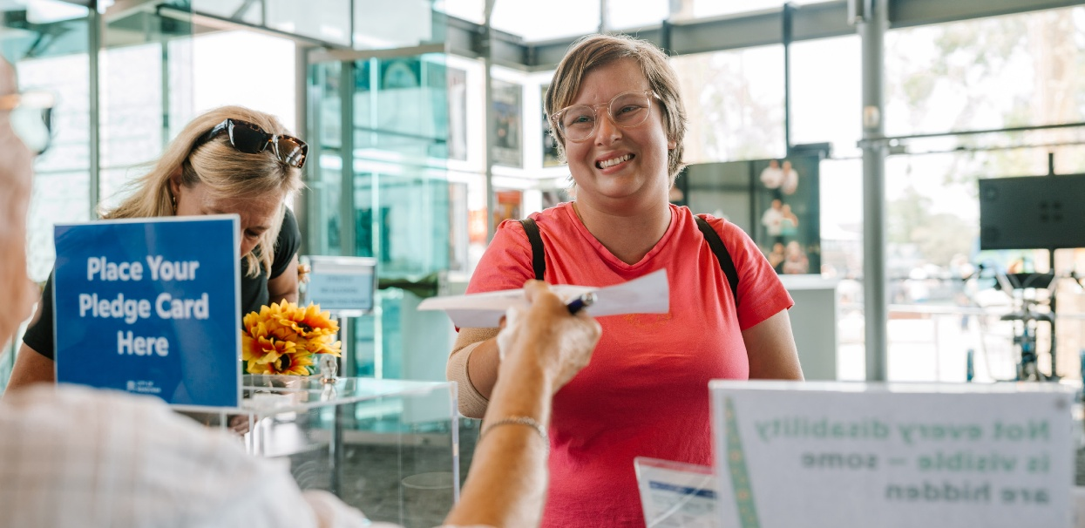

Outcome Five:
People with disability can make complaints and provide feedback to the City of Mandurah using accessible and inclusive processes.
- Ensure complaint and feedback processes are clear, accessible, and easy to use.
- Improve community awareness of the available channels to raise concerns, provide feedback or make a complaint to the City.
- Enhance transparency and accountability by communicating how feedback from the community informs decisions and leads to action.

Projects/Actions | Existing Endorsed Long Term Financial Plan Operating Budget | Measures of Success | Lead | Organisational Partners
5.1.1 Provide accessible options for complaint and feedback processes by offering multiple channels—including mobile-friendly, online, and paper-based options to support all users. | - Year 1: FY 26/27  - Year 2: FY 27/28 (Review)  - Year 3: FY 28/29  - Year 4: FY 29/30  - Year 5: FY 30/31 (Review) | 1. Accessible online and paper complaint forms available.  2. Information promoted through City channels. | Coordinator Heritage and Community Capacity | Manager Governance and Legal Services
5.1.2 Develop an Easy Read ‘how to make a complaint’ guide to support all users. | - Year 2: FY 27/28  - Year 5: FY 30/31 (Review) | 1. Easy Read ‘how to make a complaint’ guide published.  2. Information promoted through City channels. | Coordinator Heritage and Community Capacity | Manager Governance and Legal Services
5.2.1 Create mandatory training for City officers to ensure staff are aware of accessible complaints process and know how to support people to use the complaints process. | - Year 1: FY 26/27 (Training)  - Year 2: FY 27/28  - Year 3: FY 28/29  - Year 4: FY 29/30 (Training)  - Year 5: FY 30/31 | 1. Online training explaining how to give feedback and make a complaint developed.  2. Published in online training portal. | Marketing and Communications Officer Community Services | Coordinator Heritage and Community Capacity
5.2.2 Promote complaint and reporting options through community engagement activities. | - Year 1: FY 26/27  - Year 2: FY 27/28  - Year 3: FY 28/29  - Year 4: FY 29/30  - Year 5: FY 30/31 | 1. Complaint and reporting options promoted through community engagement activities.  2. Promotion incorporated into relevant events and outreach initiatives. | Coordinator Heritage and Community Capacity | Manager Advocacy and Engagement
5.3.1 Strengthen collection and analysis of feedback data. | - Year 2: FY 27/28  - Year 3: FY 28/29  - Year 4: FY 29/30  - Year 5: FY 30/31 | 1. Feedback data analysed for access and inclusion trends.  2. Findings inform planning. | Service Lead | Coordinator Information Management

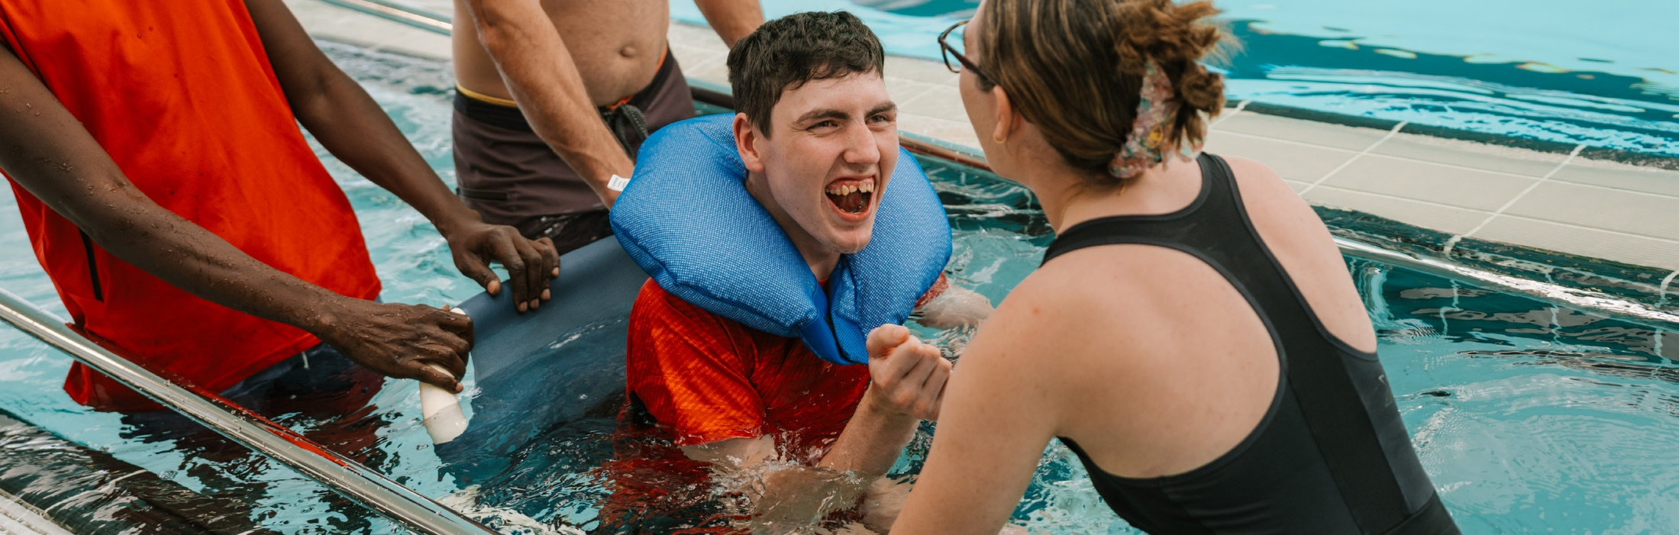

Outcome Six:
People with disability can participate in City of Mandurah public consultations through accessible and inclusive engagement methods.
- Engage people with disability early and throughout the planning and delivery of City projects to support meaningful participation in decision-making.
- Provide flexible, accessible, and inclusive consultation methods that accommodate diverse access and communication needs.

Projects/Actions | Existing Endorsed Long Term Financial Plan Operating Budget | Measures of Success | Lead | Organisational Partners
6.1.1 Promote the Access and Inclusion Advisory Group (AIAG) internally, to ensure City officers know how to suitably engage this group in a timely, relevant and meaningful way. | - Year 1: FY 26/27  - Year 2: FY 27/28  - Year 3: FY 28/29  - Year 4: FY 29/30  - Year 5: FY 30/31 (Review) | 1. AIAG promoted internally through at least one employee newsletter article and one intranet feature each year.  2. AIAG information flyer made available to employees. | Executive Manager Community Services | Coordinator Heritage and Community Capacity
6.1.2 Engage the Access and Inclusion Advisory Group (AIAG) in timely planning of major public space and infrastructure projects. | - Year 1: FY 26/27  - Year 2: FY 27/28  - Year 3: FY 28/29  - Year 4: FY 29/30  - Year 5: FY 30/31 | 1. AIAG engaged in early planning of major public space and infrastructure projects.  2. Feedback documented and considered.  3. Project teams report back on how feedback was addressed. | Director Built and Natural Environment | Executive Manager Community Services  Executive Manager Built Environment  Executive Manager Natural Environment
6.1.3 Update the Council report template to prompt engagement with the Access and Inclusion Advisory Group (AIAG) for City projects. | - Year 1: FY 26/27 | 1. Council report template updated to include a prompt regarding engagement with the AIAG.  2. Update communicated to relevant teams. | Director Business Services | Executive Manager Community Services
6.1.4 Promote City feedback and engagement opportunities to people with disability using clear and varied methods. | - Year 1: FY 26/27  - Year 2: FY 27/28  - Year 3: FY 28/29  - Year 4: FY 29/30  - Year 5: FY 30/31 | 1. Feedback and engagement opportunities promoted in accessible formats.  2. Information distributed to identified disability networks and community organisations. Distribution channels recorded. | Manager Advocacy and Engagement | Coordinator Heritage and Community Capacity
6.2.1 Develop and share a guide to support City employees to plan and deliver accessible and inclusive community engagement. | - Year 2: FY 27/28 | 1. Accessible and inclusive community engagement guide developed.  2. Guide shared with staff and available internally.  3. Guide used in engagement planning. | Coordinator Heritage and Community Capacity | Manager Advocacy and Engagement
6.2.2 Provide a Plain English option for all City community engagement and consultation materials to support clear understanding and participation. | - Year 1: FY 26/27  - Year 2: FY 27/28  - Year 3: FY 28/29  - Year 4: FY 29/30  - Year 5: FY 30/31 | 1. Plain English option included as a standard requirement in engagement briefs and templates.  2. Plain English versions published for identified community engagement activities. | Manager Advocacy and Engagement | Coordinator Heritage and Community Capacity
6.2.3 Embed inclusive and accessible feedback pathways within Mandurah Matters and provide clear guidance to support community members to navigate and contribute feedback. | - Year 1: FY 26/27  - Year 2: FY 27/28  - Year 3: FY 28/29 (Review)  - Year 4: FY 29/30  - Year 5: FY 30/31 | 1. Alternative feedback pathways (e.g. phone, email, in-person and Easy Read guidance) incorporated into Mandurah Matters pages.  2. Step-by-step ‘how to provide feedback’ guide developed and published. | Manager Advocacy and Engagement | Coordinator Heritage and Community Capacity
6.2.4 Develop a Guide to Council Meetings, including a visual story, to educate community on how to engage and participate in the City’s Council meetings. | - Year 2: FY 27/28  - Year 5: FY 30/31 (Review) | 1. Guide to Council meetings produced and utilised by the community.  2. Feedback from community on improved access and knowledge. | Executive Manager Communications and Civic Affairs | Executive Manager Community Services
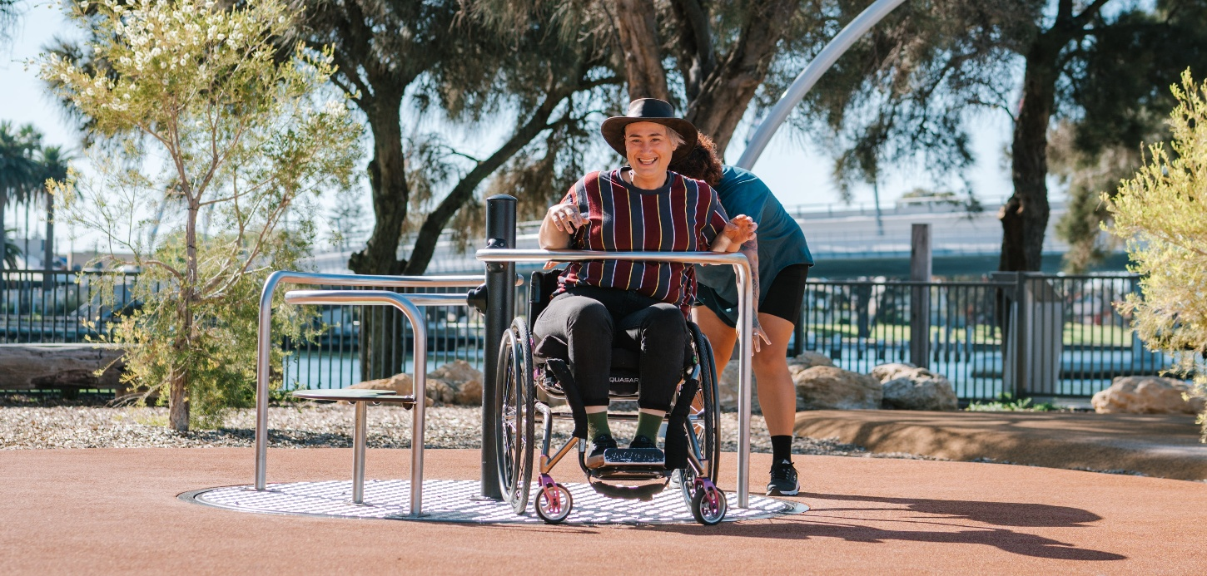

Outcome Seven:
People with disability can access City of Mandurah employment and volunteering opportunities.
- Broaden employment opportunities through accessible recruitment and workplace practices.
- Expand and enhance volunteer and work experience opportunities within the City.
- Support economic participation by identifying and promoting local micro-enterprise, entrepreneurship and self-employment opportunities.

Projects/Actions | Existing Endorsed Long Term Financial Plan Operating Budget | Measures of Success | Lead | Organisational Partners
7.1.1 In conjunction with the City’s Workforce Plan develop training and information for People Leaders to ensure people with disability have employment opportunities. | - Year 3: FY 28/29  - Year 4: FY 29/30  - Year 5: FY 30/31 | 1. Mandatory training completed by all People Leaders. | Manager People Services | Executive Manager Community Services
7.1.2 Deliver and maintain a disability employment traineeship in collaboration with a local disability employment provider. | - Year 1: FY 26/27  - Year 3: FY 28/29  - Year 5: FY 30/31 | 1. Traineeships available at the City at the completion of the current DAIP. | Executive Manager Community Services | Manager People Services
7.1.3 Educate the City’s People Leaders about the job carving process to design flexible, customised employment opportunities for people with disability. | - Year 2: FY 27/28  - Year 3: FY 28/29  - Year 4: FY 29/30  - Year 5: FY 30/31 | 1. A documented job carving framework is developed and endorsed for use across the organisation.  2. Hiring managers receive guidance or training on implementing job carving and inclusive recruitment practices. | Executive Manager Community Services | Manager People Services
7.1.4 Review and update the City’s template for job vacancy advertisements to clearly communicate accessibility and inclusion information. | - Year 1: FY 26/27  - Year 3: FY 28/29  - Year 5: FY 30/31 | 1. A formal review of the current job advertisement template is completed, including input from people with disability.  2. Job advertisements clearly outline workplace adjustments, flexible work options and multiple ways to apply.  3. Advertisements are available in accessible formats (e.g. accessible PDF and web format), with alternative formats available on request. | Manager People Services | Executive Manager Community Services
7.1.5 Develop a visual story for attending an interview template to support accessible interviews. | - Year 2: FY 27/28 | 1. Visual Story template developed to support candidates attending interviews.  2. Template made available to recruiting managers and People Services.  3. Use of the template promoted as part of accessible recruitment practices. | Coordinator Heritage and Community Capacity | Manager People Services
7.2.1 Deliver one volunteering pathways workshop for people with disability each year. | - Year 2: FY 27/28  - Year 4: FY 29/30 | 1. One volunteering pathways workshop delivered each year during National Volunteer Week.  2. Relevant City teams and external partners engaged to provide information on volunteer roles. | Executive Manager Healthy Communities | Coordinator Heritage and Community Capacity
7.2.2 Continue to promote inclusive volunteer opportunities at the City of Mandurah, including Crab Fest. | - Year 1: FY 26/27  - Year 2: FY 27/28  - Year 3: FY 28/29  - Year 4: FY 29/30  - Year 5: FY 30/31 | 1. Presentation about volunteering at Crab Fest presented at Mandurah Disability Network meeting.  2. A ‘how to volunteer’ Easy Read guide developed. | Executive Manager Healthy Communities | Coordinator Festivals and Events  Health Promotion Officer
7.2.3 Provide accessible information at the Mandurah Jobs Fair on employment, customised employment, traineeship and volunteer pathways at the City. | - Year 1: FY 26/27  - Year 2: FY 27/28  - Year 3: FY 28/29  - Year 4: FY 29/30  - Year 5: FY 30/31 | 1. Accessible employment information is developed and made available at the Mandurah Jobs Fair, including clear pathways for employment, customised roles, traineeships and volunteering.  2. Staff attending the Jobs Fair are briefed on inclusive recruitment pathways and workplace adjustments. | Manager Economic Development  Executive Manager Community Services  Manager People Services | Health Promotion Officer  Coordinator Heritage and Community Capacity
7.3.1 Strengthen inclusive economic participation by promoting opportunities for micro-enterprises to participate in City events and advocating for their inclusion across community events and activities. | - Year 2: FY 27/28  - Year 3: FY 28/29  - Year 4: FY 29/30  - Year 5: FY 30/31 | 1. Opportunities for micro-enterprises led by people with disability, are actively promoted in City event expressions of interest and vendor processes.  2. The number of micro-enterprises participating in City events increases over the life of the Plan.  3. Event planning guidelines incorporate inclusive vendor participation considerations. | Coordinator Heritage and Community Capacity | Coordinator Festivals and Events  Coordinator Arts and Culture
7.3.2 Recognise and support the expertise of people with disability through paid self-employment opportunities. | - Year 1: FY 26/27  - Year 2: FY 27/28  - Year 3: FY 28/29  - Year 4: FY 29/30  - Year 5: FY 30/31 | 1. A clear practice is established that people with disability engaged in roles such as guest speakers are offered payment for their expertise.  2. Payment rates are transparent and consistent with the value of professional lived experience expertise. | Coordinator Heritage and Community Capacity | Coordinator Festivals and Events  Coordinator Arts and Culture
7.3.3 Continue to deliver opportunities for Australian Disability Enterprises to be engaged as contractors through City procurement and contract processes. | - Year 1: FY 26/27  - Year 2: FY 27/28  - Year 3: FY 28/29  - Year 4: FY 29/30  - Year 5: FY 30/31 | 1. Procurement practices continue to enable the engagement of Australian Disability Enterprises where appropriate.  2. Australian Disability Enterprises are considered in relevant purchasing and contract processes. | Manager Commercial Services | Coordinator Heritage and Community Capacity

Disability, Access and Inclusion Guiding Principles
This Plan is guided by a set of principles that shape how the City of Mandurah approaches disability access and inclusion across all its services and activities. These principles are based on recognised approaches used in Australia and internationally, including the Social Model of Disability, Universal Design, and Asset-Based Community Development. Together, these approaches inform policy, planning, and community practice, and support decision-making that improves accessibility, participation, and inclusion for people with disability.

Understanding disability through the social model
The social model of disability recognises that disability is influenced by the way environments, systems and structures are designed. Participation can be limited when places, information or processes do not consider a range of access needs. When environments and systems are inclusive and accessible, people with disability can participate and contribute to community life. Disability itself is not the reason a person experiences barriers to participating in community life.
In a local government context, this means making informed design decisions that support participation within available resources. Planning buildings, playgrounds, events and information so they can be used by more people supports broader community involvement. Designing with access and inclusion in mind strengthens public spaces and services for everyone, including people with disability, older people, families, visitors and those with temporary access needs.

Valuing strengths through Asset-Based Community Development
This Plan is informed by Asset-Based Community Development. This approach recognises the strengths, skills, relationships and lived experience within the community. People with disability are contributors to Mandurah’s social, cultural and civic life.
Working alongside community members, organisations and networks supports practical solutions that are locally relevant and informed by lived experience.

Accessibility and inclusion
Accessibility and inclusion are closely linked but not the same. Accessibility is about how people can use spaces, services and information in ways that support independence and choice. Inclusion is about what happens once people are there. It reflects whether people feel welcomed, respected and able to take part, share ideas, build connections and contribute to community life. When considered together, accessibility and inclusion support meaningful involvement and contribution across community life.

Universal design
Universal design supports both accessibility and inclusion. It involves designing spaces, information and experiences to work for a wide range of people as part of normal planning and delivery. Considering universal design early supports efficient use of resources and reduces the need for later changes. This approach improves usability and flexibility for the whole community while supporting people with disability.

Shared responsibility and partnership
Disability access and inclusion is a shared responsibility across the City of Mandurah and requires coordinated action across teams. This work is strengthened and made more sustainable through meaningful partnerships with people with disability and the broader community. The City values the lived experience, ideas, and feedback of people with disability and the community, recognising that these insights help inform planning and decision-making, leading to more accessible and inclusive outcomes for people with disability and the wider community.
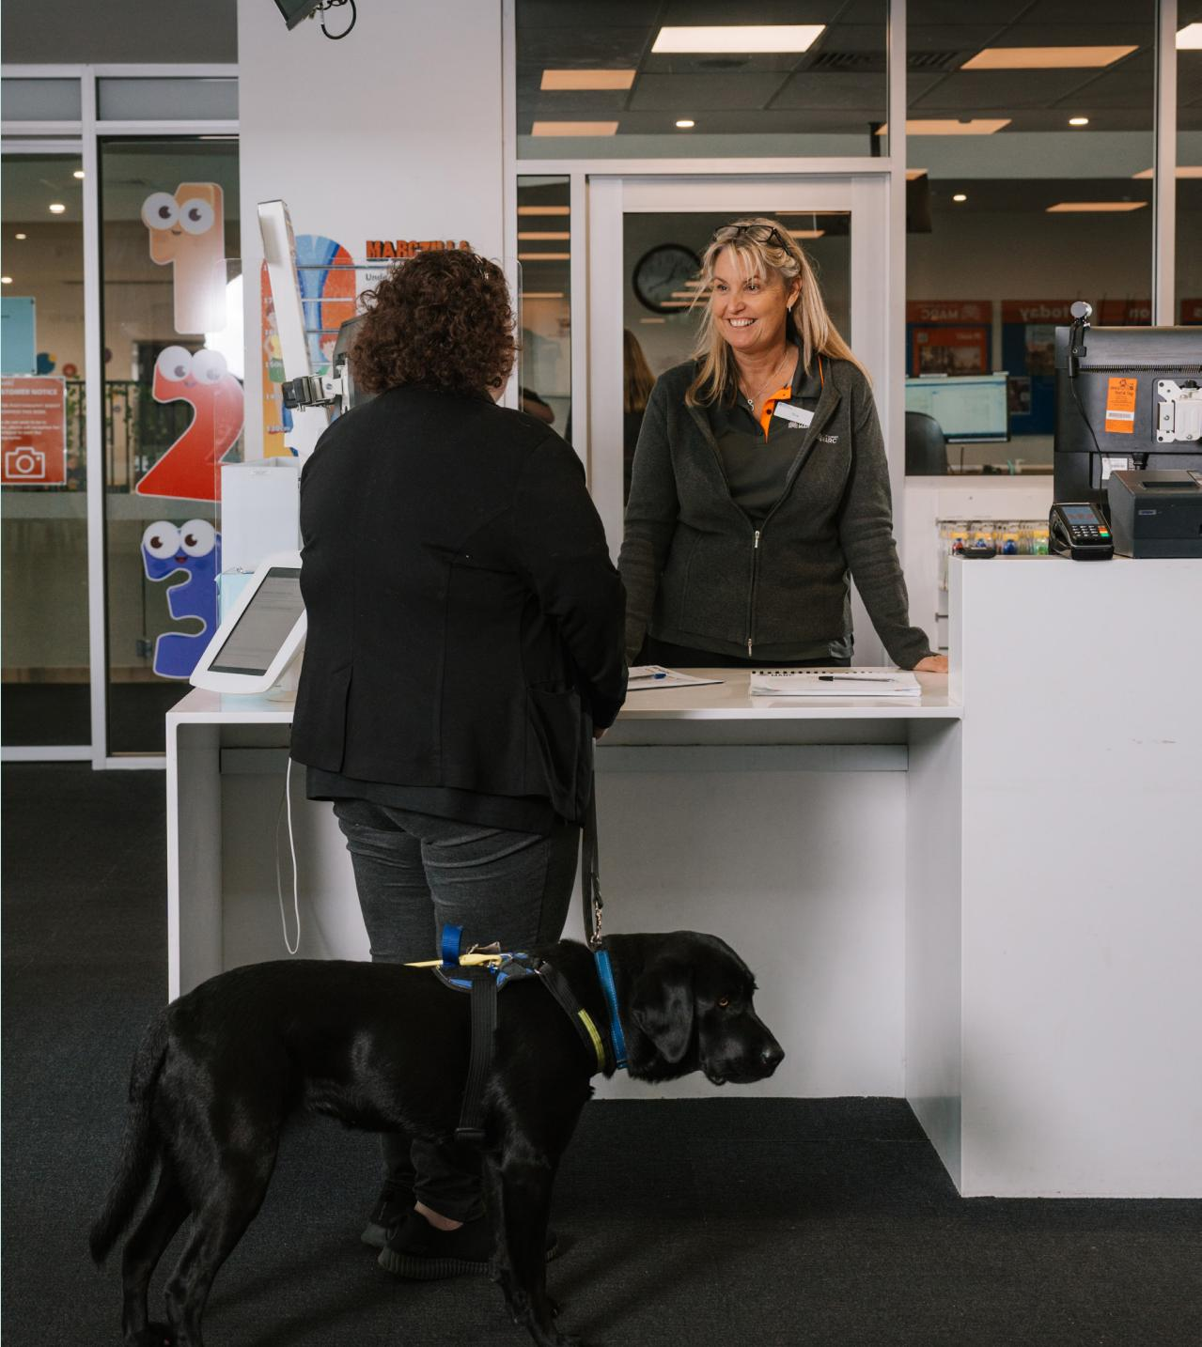

Language used in this Plan
The City of Mandurah uses person-first language when referring to disability in this Plan. This approach aligns with the Disability Services Act 1993 (WA) and reflects the City’s communication practices.
Person-first language places the person before the disability. For example, people with disability. It recognises the person first and acknowledges that disability is one part of a person’s identity.

Contact Us
City of Mandurah
Email: council@mandurah.wa.gov.au
Website: mandurah.wa.gov.au
Phone: 9550 3777
The National Relay Service (NRS) assists people who are Deaf or have difficulty hearing or speaking on the phone, offering various call services tailored to different needs and preferences.
For more information visit: Access Hub: accesshub.gov.au
This information is available in alternative formats on request.

